DUY TAN UNIVERSITY
FACULTY OF INFORMATION TECHNOLOGY



INDIVIDUAL PROJECT

TOPIC: Book management

Student: Nguyễn Văn Duy Mạnh
Student code: 29211100024
Class: CMU-CS 303 GIS

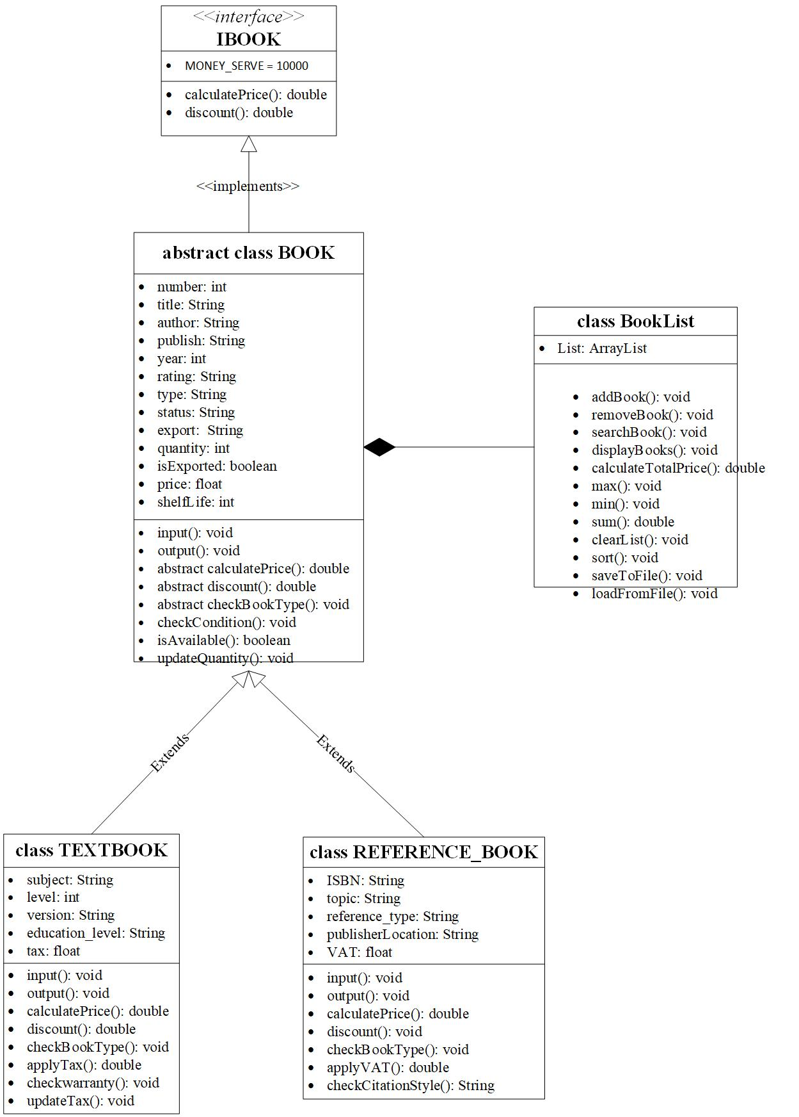

Figure 1 : Book
Create interface class: IBook
- Properties:

Create parent class: Book
- Properties:
- int number: Numerical order
- String title: Title name
- String author: Author name
- String publishing: Publishing name
- int year: Year of publication
- String rating: Product reviews
- String export: Origin of the book
- int quantity: Number of books
- String type: Book genre
- float price: Price of the book
- String status: The condition of the product, new or old
- int shelfLife: List lifetime
- boolean isExported: Indicates whether the book has been published or not
- Method:
- Create an input() method to import all the above properties into
- Create an output() method to output all the above properties
- Create a calculatePrice() abstract method to calculate the total price of book in stock
- Create a discount() abstract method to check the discounted price of the book
- Create a checkCondition() method to check book status
- Create isAvailable() method to check book availability
- Create updateQuantity() method to update book quantity

Create subclass: TextBook extend Book class
- Properties:
- String subject: Subject name
- String level: Book level
- String version: Published version
- float tax: Tax on textbook
- String educationLevel: Education level
- Method:
- Implement the input() method of this class by calling input() from the parent class and importing new properties from this child class.
- Implement the output() method of this class by calling output() from the parent class and exporting new properties in this child class
- Implement the calculatePrice() method of this class as follows:
float sum=0;
sum = quantity * price + tax*price – discount()
- Implement the discount() method of this class by calling discount() from the parent class and exporting new properties in this child class
- Create a checkwarranty() method to check if the product is still under warranty
- Implement the checkBookType() method of this class by calling checkBookType() from the parent class and exporting new properties in this child class
- Implement the book_import_fee() method of this class by calling book_import_fee() from the parent class and exporting new properties in this child class

Create subclass: ReferenceBook extend Book class
- Properties:
- String topic: Topic name
- String reference_type: Name of reference book
- float VAT: Enter VAT value
- String citation-style: Enter citation-style
- Method:
- Implement the input() method of this class by calling input() from the parent class and importing new properties from this child class.
- Implement the output() method of this class by calling output() from the parent class and exporting new properties in this child class
- Implement the calculatePrice() method of this class as follows:
float sum=0;
sum = quantity * price + VAT*price – discount()
- Create a checkbook() method to check if a book is still under warranty
- Implement the discount() method of this class by calling discount() from the parent class and exporting new properties in this child class
- Create checkBookType() abstract method to helps classify books accurately, supports management and searching for books by type.
- Create book_import_fee() abstract method to help us calculate the cost of imported books

Create a BookManager class to manage books containing some methods:
a) inputlist(): Import information from all lists
b) outputlist(): Show information from all lists
c) max(): Show the book with the highest unit price
d) min() : Show the book with the lowest unit price
e) sumlist(): Calculate the total price of both types of books
f) timsach(): Find the type of book you are looking for
g) insert(): Insert the book at any position in the list
h) delete(): Delete a book at any position in the list
i) sort(): Sort the book list in ascending or descending order by unit price
j) writeToFile(): opens a file products.txt, writes the list to it, and closes the file.
k) readFromFile(): opens the file products.txt and displays its contents.

